**Vanier College**

**Faculty of Science and Technology**

**System Development 420-436-VA**

Deliverable 04

**Grey Team**

Gennaro Finelli

Mohammed Hosein Ali

Alexandre Pham

Wayne De Leon

In collaboration with CyberStation

**(Code from our eCommerce class will be used for certain features of this project)**

**We, the Grey Team, certify that this assignment is our own work**

I, Gennaro Finelli, student ID# 2268107, certify that I have contributed to this deliverable, G.F

I, Mohammed Hosein Ali, student ID# 2055295, certify that I have contributed to this deliverable, M.H.A

I, Alexandre Pham, student ID# 2048017, certify that I have contributed to this deliverable, A.P

I, Wayne De Leon, student ID# 2179710, certify that I have contributed to this deliverable, W.D

Table of Contents

Executive Overview 3

Client/Business 4

Business Domain 4

Business Environment 4

Description of Client 4

Business Problem 4

Narrative Description 5

Appendix 1 6

Appendix 2 7

Appendix 3 8

Appendix 4 9

Appendix 5 10

References 11

Project Plan 12

# Executive Overview

Cyber Station is a gaming lounge that provides its customers the opportunity to play video games, while being able to be served food and drinks to enhance the experience. It combines the ideas of an arcade with the latest consoles. Cyber Station has a great business environment but can be further developed an added online presence. Cyber Station has some current advertising through Instagram, and other websites that review Cyber Station, however they don’t have a website of their own. The staff is very friendly, and the business has great reviews. Our website will help the client and her staff with the organization of their reservations.

Over the course of this deliverable, we booked a meeting with our client, which happened on the 10th of September. During the meeting we asked our client questions about what she wants on the webpage. We then translated the customer requirements to our user stories.

For deliverable 3 we used Jira in order to help organize all our user stories. The user stories were made based on the answers to the questions we asked our client. We then created a test for each of our user stories, based on our clients’ requirements. Finally, we separated the user stories into their appropriate section in the story map.

# Client/Business

## Business Domain

Cyber Station is a gaming lounge. According to Taryn Hefner, who made a blog on Join It, gaming lounges provide its customers with the opportunity to play video games. It can also include tournaments, cosplay contests, networking events and other events. It combines the idea of an arcade with the latest games and consoles. Certain gaming lounges provide food and drinks to customers to make it more of a hang out spot.

## Business Environment

Cyber Station has a great business environment, but everything can be developed with added online presence which will be done along the process of this project. Currently, Cyber Station has some advertising through the internet in the form of Instagram and other websites that review the platform, but it is missing its own website. Not only does creating its own website boost the business’ online presence but also helps the staff have an easier time doing their job. Reservations of consoles will also aid customers see if a spot is free or reserved so they can manage their time better. The staff is very friendly, and the business has a great review online. In all, the business has a great environment for both the staff and the customers.

## Description of Client

Our client’s name is Sarah Chahrour, she is currently running a gaming lounge located in the airport called, CyberStation, where she provides a gaming station for customers to pass time as they wait for their flights. She offers times for customers to book a gaming station for a set amount of time.

Our client does not have any computer/programming skills. She will not be the only one able to access the project we make; her workers will also have access to view the project we develop.

## Business Problem

Our client has no website for her gaming café business. So, she would like for us to make her a web application so clients can have an overview of her business. In the website, clients will be able to make reservations because clients usually line up in front of the store and don’t know the estimate of when they’ll be able to reserve spot. Additionally, they can also read up more about the business. Also, employees will be able to track reservations and CRUD their status’.

Lastly, the client writes all of her gross sales and cash profit with pen and paper. For that reason, she would like an additional feature to track sales (sales tracker) and automatically calculate the total, etc.

# Narrative Description

# Appendix 1

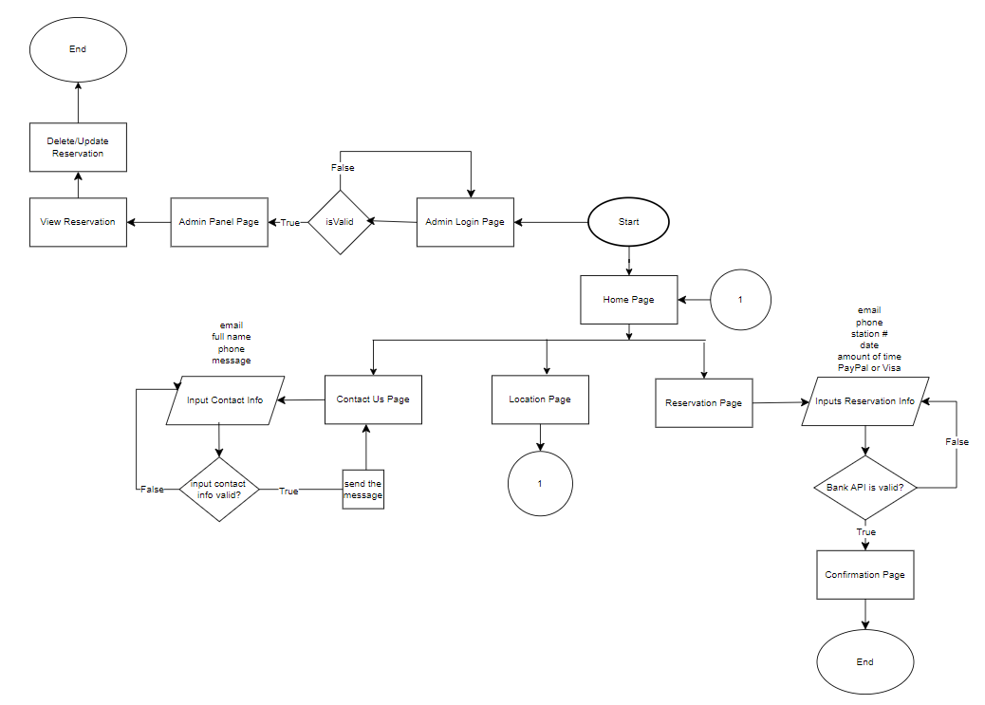

# Appendix 2

# Appendix 3

SEQUENCE DIAGRAM UML DIAGRAM

# Appendix 4

A UML CLASS DIAGRAM FOR THE ENTIRE EXISTING INFORMATION SYSTEM

# Appendix 5

COPIES OF FORMS AND OTHER DOCUMENTS USED BY CLIENT IF THERE ARE VERY MANY, THEN ONLY INCLUDE SAMPLES. IF THERE ALREADY IS A COMPUTER SYSTEM, INCLUDE SCREEN SHOTS.

# References

Hefner, T. (2022, May 3). *What is a gaming lounge?*. Join It. <https://joinit.com/blog/what-is-a-gaming-lounge#:~:text=It%20can%20also%20include%20tournaments,of%20a%20hang-out%20hub>.

# Project Plan

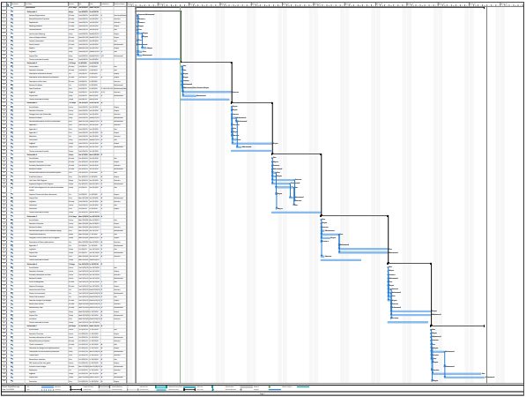

<https://drive.google.com/file/d/1lCVqBy63ZIDcD1_eCIk4fwLjSIlaVcDq/view?usp=sharing>